The Great Plains IDeA-CTR (GP IDeA-CTR) is a collaboration of 6 institutions eligible for funding which include: Boys Town National Research Hospital, Creighton University, University of Nebraska Kearney, University of Nebraska-Lincoln, University of Nebraska Medical Center, and University of Nebraska Omaha.

Specialty Pilot Funding Announcement:

Biostatistics, Epidemiology, and Research Design

Novel Methodology Development

Full Submission Guidelines

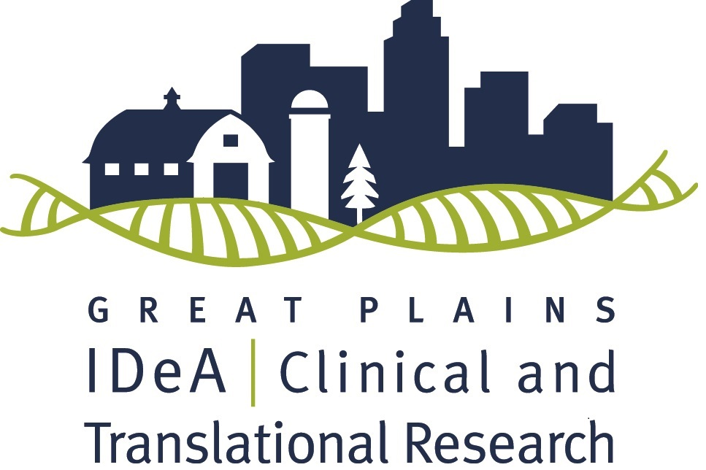

Deadline: November 30th, 2020 by 5 PM
The Great Plains IDeA-CTR Network is pleased to announce an opportunity for Biostatistics, Epidemiology, and Research Design Methodology Pilot funding through an NIH/NIGMS grant. Successful applicants will receive up to $30,000 in direct costs for a one-year project, as well as access to resources of the Great Plains IDeA-CTR to support their research efforts.
*Funding is dependent upon the renewal of the Great Plains IDeA-CTR grant.
Earliest starting date will be July 1, 2021.
Questions? Contact Jerrod Anzalone (alfred.anzalone@unmc.edu)

If you have any questions contact Heather Braddock or call 402.559.9870.

The purpose of this funding program is to promote development and use of novel statistical methodological tools. The goal is to support investigators in obtaining extramural funding for developing novel statistical and research design methodology.

Funding available through this program totals up to $30,000. The award will support a project that can be completed within one year. Awards may pay for wages and salaries of graduate student, software, datasets, travel, or other appropriately justified expenses. Please reference the budget description below for a full list of allowable and unallowable expenses.

Methodological Development: The application must detail an existing or developing project including improving or developing novel statistical, epidemiology or research design methodology.
Applicable Research: The methodology development project must fall along the translational research spectrum encompassing pre-clinical research, clinical research, clinical implementation research and public health research. The GP IDeA-CTR does not fund basic research projects. As broadly defined by the NIH IDeA-CTR Program, “Clinical research” comprises studies and trials in human subjects as defined by NIH Regulations and Policies, and “Translational research” includes research that aims to convert basic research advances to practical applications in humans and research aimed at the adoption of best practices in community healthcare. In addition, we note the following definitions, here, to provide further clarity for researchers in determining whether their projects fall on the translational research spectrum.
Basic Research - Basic research involves scientific exploration that can reveal fundamental mechanisms of biology, disease or behavior. (This research will not be funded by the Great Plains IDeA-CTR Pilot Grant program).
Pre-Clinical Research - Pre-clinical research connects the basic science of disease with human medicine. During this stage, scientists develop model interventions to further understand the basis of a disease or disorder and find ways to treat it. Testing is carried out using cell or animal models of disease; samples of human or animal tissues; or computer-assisted simulations of drug, device or diagnostic interactions within living systems.
Clinical Research - Clinical research includes studies to better understand a disease in humans and relate this knowledge to findings in cell or animal models; testing and refinement of new technologies in people; testing of interventions for safety and effectiveness in those with or without disease; behavioral and observational studies; and, outcomes and health services research.
Clinical Implementation - The clinical implementation stage of translation involves the adoption of interventions that have been demonstrated to be useful in a research environment into routine clinical care for the general population. This stage also includes implementation research to evaluate the results of clinical trials and to identify new clinical questions and gaps in care.
Public Health - In this stage of translation, researchers study health outcomes at the population level to determine the effects of diseases and efforts to prevent, diagnose and treat them. Findings help guide scientists working to assess the effects of current interventions and to develop new ones.

Applicants are required to identify the level of research as pre-clinical, clinical, clinical implementation or public health.
For additional questions regarding whether your research satisfies this definition, please contact your local institutional program coordinator (see ‘Eligible Institutions and Contacts’ below). Alternatively, if you have questions about whether your research will be considered eligible, you may contact Dr. Fang Yu fangyu@unmc.edu or Dr. Shinobu Watanabe-Galloway at swatanabe@unmc.edu. Basic science projects (e.g., those using only animal models or cell lines that are not of direct relevance to human health/disease) will not be considered.
Research Priorities: Priorities include a combination of scientific and regional needs developed by the GP IDeA-CTR Scientific Team and Community Advisory Board. Priority areas are:
- Behavioral health including, mental health, substance abuse (e.g., opioids and alcohol), and violence as a public health issue
- Obesity treatment and prevention
- Aging and age-related cognitive impairment
- Injury prevention
- Technologies and models to improve health access including the evaluation of new or existing tools (e.g., telehealth) with a focus on rural populations
- Connecting clinical care and community services (e.g., schools, food banks, YMCA’s)
- Addressing health disparities based on social determinants, race, ethnicity, and geography
Highest priority will be given to the strongest science and projects that focus on priority areas which are most likely to lead to successful extramural funding. Projects that make an impact on medically disadvantaged, underrepresented minority, and/or geographically or clinically isolated populations are of high interest. In addition, projects that can introduce or evaluate new tools or technologies useful in these populations are strongly encouraged.
Interdisciplinary and collaborative approaches: To increase the likelihood of a strong scientific proposal, applicants are encouraged to engage in new interdisciplinary or inter-institutional collaborations, and to develop links to other existing IDeA programs (INBRE and COBRE) in the participating Great Plains region. Applicants are encouraged to consider recruitment of subjects or utilization of data from clinics or Practice-Based Research Networks (PRBN).
Eligibility:
- At least one of the Principal Investigators must have a current full-time faculty appointment at a participating institution
- Eligible to apply for NIH research grants
- Has a focus on relevant clinical, clinical-translational, or community-translational research
- Note: You are not eligible if you have funding from any other IDeA-CTR program that will overlap at the time of this award.

Eligible Institutions and Contacts:
- Boys Town National Research Hospital (BTNRH) – Chris Stecker (chris.stecker@boystown.org)
- Creighton University (CU) – Peter Steyger (petersteyger@creighton.edu)
- University of Nebraska at Kearney (UNK) – Kimberly Carlson (carlsonka1@unk.edu)
- University of Nebraska-Lincoln (UNL) – David Hansen (dhansen1@unl.edu)
- University of Nebraska Medical Center (UNMC) – Sarah Holstein (sarah.holstein@unmc.edu)
- University of Nebraska at Omaha (UNO) – Sara Myers (samyers@unomaha.edu)

Full Application Deadline: November 30th, 2020
Earliest Funding Start Date: July 1st, 2021 (pending review, NIH, and all other regulatory approvals)
Application Process:
- Applicants are encouraged to consult with a biostatistician or epidemiologist in preparation of this application. If a biostatistician or other statistical support is not available at your institution, or you are located at UNMC, please complete a request for services through CCORDA, here, so that we can identify the appropriate Biostatistics, Epidemiology & Research Design (BERD) statistical consultant for your work. If you have questions, please contact Dr. Fang Yu, or call 402-559-9436.
- The BERD Core is funded to support the pilot project investigators on developing the pilot proposals and data analysis for the awarded pilot projects. There is no need to budget the statistician time for your pilot proposal.
- Applying to the program is done centrally through UNMC’s REDCap portal. Please submit your proposal here: https://is.gd/berdpilot2020
- If you are new to REDCap or have any difficulties during the application process, please contact the Research Information Technology Office (RITO) at 402-559-4878.
- Once your application has been submitted, you will receive a confirmation email from REDCap. In addition, you will receive a copy of your submission within two business days from Jerrod Anzalone: alfred.anzalone@unmc.edu. You must review the document carefully to ensure that all pages have been received and reply to the email whether or not the document is accurate.
Full proposal required application materials:
Compile the documents listed below in REDCap in the following order:
      - NIH Face Page (download and complete Form Page 1 here). This does not need to be signed by an institutional official, but we strongly encourage you to work with your Grants Administrator or Sponsored Programs office to ensure that all fields on the NIH Face Page are complete and correct.
        - Project dates will be July 1st, 2021 – June 30th, 2022.
- NIH format Biosketch (download here). A biosketch must be included for all principal investigators, co-investigators and all other key personnel.
- Project summary (limited to 30 lines or less of text, .5 margins, Arial size 11)
  - Include the project’s broad, long-term objectives and specific aims. Include a description of the research design and methods for achieving the stated goals as well as the potential long-term impact the study could have on population health. Include a description of the composition of the research team and indicate how this research project is interdisciplinary in nature. Write in plain language, so even a non-scientist can understand the importance and impact of the project. This will be critiqued by a member(s) of the Great Plains IDeA-CTR Community Advisory Board (CAB) as well as 3 scientific reviewers. Comments and questions from the CAB member(s) will be shared with scientific reviewers and all reviews will be provided to the applicant at the end of the review process.
- Research Plan: this portion is limited to three pages in total
- Specific Aim(s)
- Research Strategy
    - Significance: The scientific premise of the proposed research--the strengths and weaknesses of the research that is used to form the basis for the proposed research question.
    - Innovation: A brief summary of how the research project moves the current field forward and incorporates novel concepts, approaches, methodologies, instrumentation or interventions. Describe how the newly formed multidisciplinary team will provide a novel approach to the research.
    - Approach: Experimental design, including steps taken to ensure scientific rigor, sample, measures, procedures, analysis, interpretation and reporting of results, explained as appropriate for a pilot project, and consideration of key biological variables, if applicable (please see guidelines here).
    - Team Development: Describe the leadership structure of the team. Describe the role of each team member in the proposed research project. Describe the plan for interaction and communication between team investigators.
- Future directions. Describe how successful completion of the proposed studies will lead to further project development, including plans for seeking additional funding opportunities.
- Literature cited (not part of the 3 pages). Please include with the Research Plan.
- If your project meets the NIH definition of human subjects research, you must include a Protection of Human Subjects section (as required by NIH grants; follow the “A Protection of Human Subjects section” which can be accessed via the link above). The Protection of Human Subjects section should also include sections for Inclusion of Women & Minorities and Inclusion of Children. You are also required to complete Human Subjects education (e.g., Collaborative IRB Training Initiative (CITI) training) and submit a copy of the certificate to the GP IDeA-CTR, if awarded.
- If your project meets the NIH definition of human subjects research and meets the new NIH definition of a clinical trial, you must check “Yes” to the clinical trial question on the NIH face page. If you are unsure whether your project meets the new NIH clinical trial definition, answer the four questions below. If the answer to all four questions is “Yes”, then your project is a clinical trial.
  - Does the study involve human participants? Yes / No
  - Are the participants prospectively assigned to an intervention? Yes / No
  - Is the study designed to evaluate the effect of the intervention on the participants? Yes / No
  - Is the effect being evaluated as a health-related biomedical or behavioral outcome? Yes / No
For additional information click here.
- If your project meets the NIH definition of vertebrate animal research, you are required to include the Vertebrate Animals items for NIH grants (Click here for instructions).
- Regulatory approvals: If your project includes human subjects or vertebrate animals, your institutional IRB or IACUC (respectively) approval is required before funds can be released.
Protocols must be submitted to IRB for approval within 30 days of notification of award and final approval sent to us within 60 days. Even if IRB approval is not needed, an exemption letter or email from the IRB is still required.
- If you are conducting a cancer study at UNMC that involves human subjects research, your protocol must be submitted simultaneously to the IRB and Scientific Review Committee (SRC) for approval from both. Please complete the “SRC New Project Form” that can be downloaded from the SRC website. For questions regarding this process, contact the Protocol Review and Monitoring System (PRMS) office at 402-559-4232. Any partner institution that requires a scientific review for cancer research must follow their institutional process for this approval.
- Budget – complete form on page 6 of this document.
- Budget Justification document outlining the rationale for all research costs is required (NIH format; on a separate page, explain all expenses that appear in the budget including duties of personnel, use of supplies, other expenses, subaward costs, etc.).
- No faculty salary support is allowed. Student/post-doctoral stipend is not allowed but student/doctoral salary/wages are permissible. Wages for technical personnel are permissible.
- Equipment (>$5,000 per item) is not allowed.
- Renovation is not allowed.
- Honorariums are not allowed.
- Travel is strictly limited to what is necessary to perform research. Neither travel for conferences nor conference fees are allowable costs.
- Indirect costs (F&A) associated with pilot grants will be awarded to the investigator’s institution for NIH-funded pilots. Please work with your Sponsored Programs office to ensure that your proposal budget includes your institution’s correct F&A rate. Additional pilot funds may be contributed by partner institutions, rather than NIH, and these institutionally designated awards will not include indirect costs.
- Provide a completed budget from subcontractor(s), only if applicable. If applicable, use the same budget template included below.
- Appendices will not be accepted.
Review Process and Scoring
      - Proposals will be reviewed and scored by reviewers selected by the IDeA-CTR Biostatistics, Epidemiology and Research Design KCA.
      - Proposals and scores will be submitted to the GP IDeA-CTR Steering Committee and External Advisory Committee for approval.
      - Highest reviewed proposals will be sent to NIH for final approval (IRB approval is required by NIH if applicable).
      - Selections will be in Mid-February.
Expectations of Pilot Awardees
- Remain current on all regulatory training and approvals and provide all updated approvals to the GP IDeA-CTR.
- Report to BERD Core leadership at 6 and 12 months.
- Complete a progress report at 6 months and a final report at the conclusion of the funding period.
- Participate in a one-hour research studio at the end of your funding period.
- Complete the NIH annual progress report.
- Become a member of the GP IDeA-CTR via our website.
- Attend the 2-day Annual Scientific Meeting where you will provide a poster to discuss during a networking session, as well as meet with and discuss your project and progress with our EAC members and NIGMS Program Officers.
- Provide follow-up for the duration of the parent grant.
- Cite the GPCTR/NIGMS grant in funding, publications, and presentations.

Questions
If you have any questions regarding this process, contact Jerrod Anzalone at alfred.anzalone@unmc.edu or the Great Plains IDeA-CTR Office at gpctr@unmc.edu or 402.552.2260.

DETAILED BUDGET FOR FULL PROPOSAL |  | Dates:  FROM  07/01/2021 |  | THROUGH  06/30/2022
NAME | FRINGE  RATE* | SALARY  REQUESTED | FRINGE  BENEFITS* | TOTAL COST
*Not to exceed fringe allowable rate from applicant’s institution; Must provide institutional documentation of fringe rate
SALARY SUBTOTAL |  |  |  | $
RESEARCH EXPENSES (Itemize by category) **

CONSULTANT COSTS

EQUIPMENT

SUPPLIES

TRAVEL (BE SURE TO REFERENCE LIMITATIONS IN BUDGET DESCRIPTION ABOVE)

OTHER EXPENSES

BUDGET JUSTIFICATION:
OTHER EXPENSES SUBTOTAL |  |  |  | $
TOTAL DIRECT COSTS FOR BUDGET PERIOD |  |  |  | $
Applications must include an itemized budget. Allowable costs include the following types of expenses: (a) research supplies, equipment and technical personnel; (b) statistical services including personnel and computer time (if required services are not available from the UNMC CCORDA) and (c) support from IDeA-CTR core facilities and data resources. These funds may not be used for administrative salary support. Funds may not be used for foreign travel or to support construction / renovations. Although stipends for graduate students and post-doctoral trainees are not allowed, wages and salary support are allowed.

