The COVID-19-related Pilots will provide up to $50,000 in funding to be spent by June, 30, 2021. Amounts over $50,000 might be considered depending on funding available and project relevance. Please contact Pamela Laws to assess project relevance before submitting a proposal with direct costs of greater than $50,000.

COVID Research Pilot Grant

Request for Applications

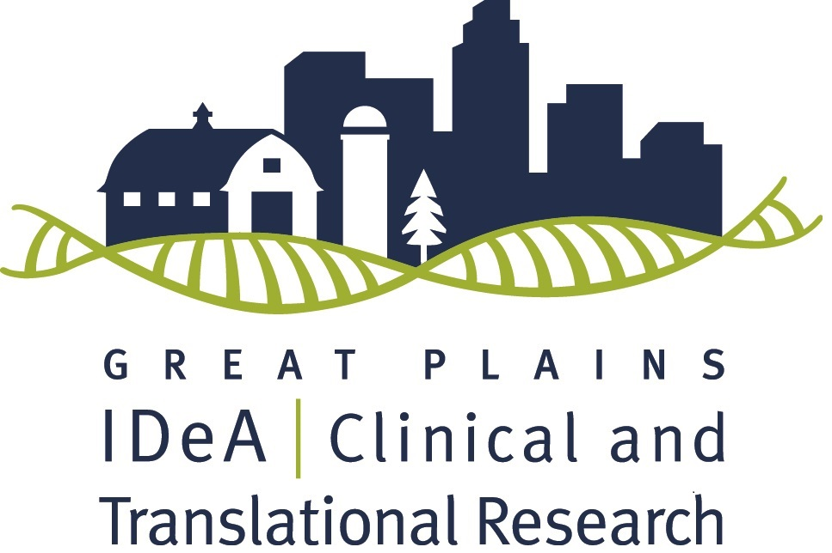

Deadline: Applications Assessed on a First-Come, First-Serve Basis.
The Great Plains IDeA-CTR Network is accepting applications for COVID-19 related Pilot funding through an NIH/NIGMS grant. Successful applicants will receive up to $50,000 in direct costs for a project that can be completed by June 30, 2021. Earliest starting date will be as soon as possible, pending committee and NIH approvals.

Please email your proposal (see details below) and NIH biosketch as a single PDF document to the Great Plains IDeA-CTR Office at gpctr@unmc.edu.

To learn more about the GP IDeA-CTR please visit our website.

If you have any questions contact Pamela Laws at pamela.flaxlaws@unmc.edu.
Applicable Research: Projects must be related to COVID-19 and fall along the translational research spectrum encompassing pre-clinical research, clinical research, clinical implementation research and public health research. The GP IDeA-CTR does not fund projects that are purely basic research. As broadly defined by the NIH IDeA-CTR Program, “Clinical research” comprises studies and trials in human subjects as defined by NIH Regulations and Policies, and “Translational research” includes research that aims to convert basic research advances to practical applications in humans and research aimed at the adoption of best practices in community healthcare. In addition, we note the following definitions, here, to provide further clarity for researchers in determining whether their projects fall on the translational research spectrum.
Basic Research - Basic research involves scientific exploration that can reveal fundamental mechanisms of biology, disease or behavior. (Such research will not be funded by the Great Plains IDeA-CTR Pilot Grant program).
Pre-Clinical Research - Pre-clinical research connects the basic science of disease with human medicine. During this stage, scientists develop model interventions to further understand the basis of a disease or disorder and find ways to treat it. Testing is carried out using cell or animal models of disease; samples of human or animal tissues; or computer-assisted simulations of drug, device or diagnostic interactions within living systems.
Clinical Research - Clinical research includes studies to better understand a disease in humans and relate this knowledge to findings in cell or animal models; testing and refinement of new technologies in people; testing of interventions for safety and effectiveness in those with or without disease; behavioral and observational studies; and, outcomes and health services research.
Clinical Implementation - The clinical implementation stage of translation involves the adoption of interventions that have been demonstrated to be useful in a research environment into routine clinical care for the general population. This stage also includes implementation research to evaluate the results of clinical trials and to identify new clinical questions and gaps in care.
Public Health - In this stage of translation, researchers study health outcomes at the population level to determine the effects of diseases and efforts to prevent, diagnose and treat them. Findings help guide scientists working to assess the effects of current interventions and to develop new ones.
Applicants are required to identify the level of research as pre-clinical, clinical, clinical implementation or public health. Basic science projects (e.g., those using only animal models or cell lines that are not of direct relevance to human health/disease) will not be considered.
Highest priority will be given to projects with the strongest science, projects with strongest impact and projects that can be feasibly completed by June 30, 2021. Projects that make an impact on medically disadvantaged, underrepresented minority, and/or geographically or clinically isolated populations are of high interest. In addition, projects that can introduce or evaluate new tools or technologies useful in these populations are strongly encouraged.
Resources:
- Awardees will have access to GP IDeA-CTR Resources.
- Applicants can consider utilizing the National COVID Cohort Collaborative (N3C) data enclave to support their research efforts. The N3C data enclave is a national platform comprised of EHR data from 65 sites and over 725, 000 patients. If you have any questions about use of the N3C data enclave, please contact Jerrod Anzalone @ alfred.anzalone@unmc.edu.
Eligibility:
- At least one of the Principal Investigators must be current full-time faculty at a participating institution
- Eligible to apply for NIH research grants
- Has a focus on relevant clinical, clinical-translational, or community-translational research
- Note: You are not eligible if the PI is the PI of funding for a research project from any other IDeA program (CTR, COBRE, INBRE) that will overlap at the time of this award.
Eligible Institutions:
- Boys Town National Research Hospital (BTNRH)
- University of Nebraska at Kearney (UNK)
- University of Nebraska-Lincoln (UNL)
- University of Nebraska Medical Center (UNMC)
- University of Nebraska at Omaha (UNO)
- University of South Dakota (USD)
- University of North Dakota (UND)
- North Dakota State University (NDSU)
Earliest Funding Start Date: As soon as possible (pending review, NIH, and all other regulatory approvals)
Funding will depend on the 1) Scientific and technical merit of the proposed project as determined by scientific peer review, 2) Availability of funds, and 3) Approval by the officials funding the grant.
Full Application Process:
      - Please put all application materials into a single pdf and submit to gpctr@unmc.edu with subject line: COVID PROPOSAL
      - The full proposal will include: 1) NIH Face Page, 2) NIH format biosketch (for all principal investigators, co-investigators and other key personnel), 3) Project Summary, 4) Research Plan (2-3 pages with five page maximum), 5) Literature cited, 6) Protection of Human Subjects (if applicable), 7) Vertebrate Animals (if applicable), 8) Budget Form and Budget Justification.
      - Note that no faculty salary support is allowed. Student/post-doctoral stipend is not allowed but student/doctoral salary/wages are permissible. Wages for technical personnel are permissible.
Review Process of Full Proposals
      - Applications will be reviewed by the GP IDeA-CTR Administrative Core.
      - The Administrative Core will make funding recommendations to the Steering Committee.
      - The Steering Committee will approve or reject recommendations for funding, and approved recommendations will be forwarded to the External Advisory Committee and NIH Program Officers for final approval.
      - Applications will be reviewed on a first-come, first-serve basis and will be reviewed within 3 weeks post-receipt.
Expectations of Pilot Awardees
- Remain current on all regulatory training and approvals and provide all updated approvals to the GP IDeA-CTR.
- Complete a report by 6/30/2021 and a final report at the conclusion of the project.
- Become a member of the GP IDeA-CTR via our website.
- Attend the 2-day Annual Scientific Meeting where you will provide a poster to discuss during a networking session, as well as meet with and discuss your project and progress with our EAC members and NIGMS Program Officers.
- Provide follow-up for the duration of the parent grant.
- Cite the GP IDeA-CTR NIGMS grant in funding, publications, and presentations.
