The Great Plains IDeA-CTR (GP IDeA-CTR) is a collaboration of 8 institutions eligible for funding which include: Boys Town National Research Hospital, Children’s Hospital and Medical Center (CHMC), Creighton University, Omaha VA Medical Center (O-VAMC), University of Nebraska Kearney, University of Nebraska-Lincoln, University of Nebraska Medical Center, and University of Nebraska Omaha.

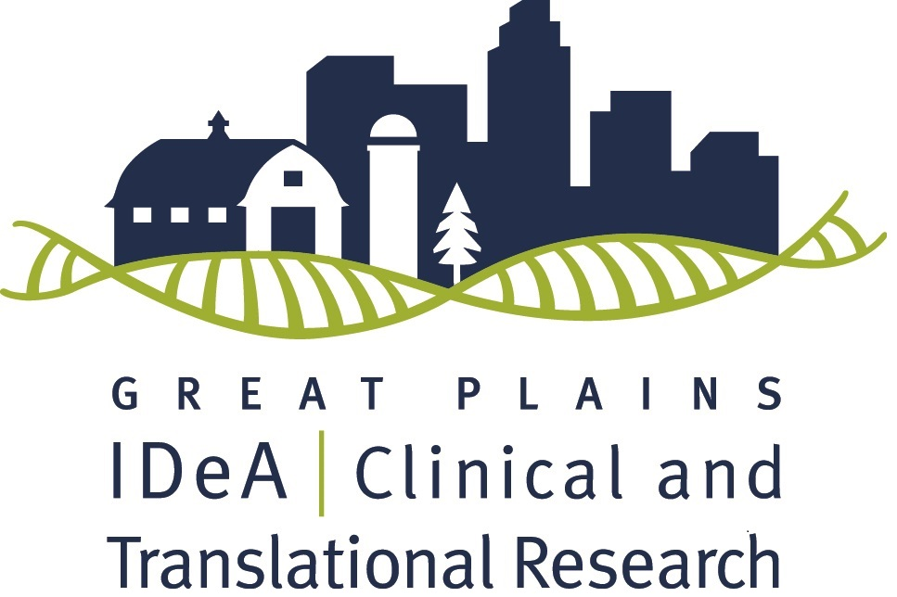

Team Research Pilot Grant

Letter of Intent Announcement

Deadline: October 7th, 2021 by 5 PM
The Great Plains IDeA-CTR Network is pleased to announce an opportunity for Team Research pilot funding through an NIH/NIGMS grant. Successful applicants will receive up to $50,000 in direct costs for a one-year project, as well as access to resources of the Great Plains IDeA-CTR to support their research efforts. Earliest starting date will be July 1st, 2022.
We are requesting a Letter of Intent (LOI) (maximum of two pages) using the template provided on page 5 at the end of the attached document. Those invited to submit full applications will be notified by October 17th, 2021 and at that time will be provided with the instructions for the full application. Solicited applications will be due November 24th, 2021.

Please email your LOI document and NIH biosketch as a single PDF document to the Great Plains IDeA-CTR Office at gpctr@unmc.edu.

To learn more about the GP IDeA-CTR please visit our website.

If you have any questions, contact Heather Braddock or call 402.559.9870.

The Team Research Pilot Program will provide up to $50,000 over one year to support existing clinical and translational research (CTR) teams/projects. Single investigators working in isolation are not eligible for this funding mechanism. Instead, there should be evidence of a team-based approach involving two or more Principal Investigators (Multi-PI) from different disciplines. The Multi-PI teams may also include co-investigators and collaborators. Evidence of the team’s prior productivity, in the form of preliminary data or publications, will be evaluated. The goal of this funding mechanism is to provide funds to enable further progress on an existing project in support of extramural applications and, in some cases, to advance a project along the translational spectrum.
Applicable Research: Team research projects must address at least one of the research priority areas (page 2) and fall along the translational research spectrum encompassing pre-clinical research, clinical research, clinical implementation research and public health research. The GP IDeA-CTR does not fund basic research projects. As broadly defined by the NIH IDeA-CTR Program, “clinical research” comprises studies and trials in human subjects as defined by NIH Regulations and Policies, and “translational research” includes research that aims to convert basic research advances to practical applications in humans and research aimed at the adoption of best practices in community healthcare. In addition, we note the following definitions, here, to provide further clarity for researchers in determining whether their projects fall on the translational research spectrum.

Basic Research - Basic research involves scientific exploration that can reveal fundamental mechanisms of biology, disease, or behavior. (This research will not be funded by the Great Plains IDeA-CTR Pilot Grant program).
Pre-Clinical Research - Pre-clinical research connects the basic science of disease with human medicine. During this stage, scientists develop model interventions to further understand the basis of a disease or disorder and find ways to treat it. Testing is carried out using cell or animal models of disease; samples of human or animal tissues; or computer-assisted simulations of drug, device or diagnostic interactions within living systems.
Clinical Research - Clinical research includes studies to better understand a disease in humans and relate this knowledge to findings in cell or animal models; testing and refinement of new technologies in people; testing of interventions for safety and effectiveness in those with or without disease; behavioral and observational studies; and outcomes and health services research.
Clinical Implementation - The clinical implementation stage of translation involves the adoption of interventions that have been demonstrated to be useful in a research environment into routine clinical care for the general population. This stage also includes implementation research to evaluate the results of clinical trials and to identify new clinical questions and gaps in care.
Public Health - In this stage of translation, researchers study health outcomes at the population level to determine the effects of diseases and efforts to prevent, diagnose and treat them. Findings help guide scientists working to assess the effects of current interventions and to develop new ones.

Applicants are required to identify the level of research as pre-clinical, clinical, clinical implementation or public health.
For additional questions regarding whether your research satisfies this definition, please contact your local institutional program coordinator (see ‘Eligible Institutions and Contacts’ on page 3). Alternatively, you may also contact the director of the Pilot Projects Program, Dr. Sarah Holstein. Basic science projects (e.g., those using only animal models or cell lines that are not of direct relevance to human health/disease) will not be considered.
Research Priorities: Priorities include a combination of scientific and regional needs developed by the GP IDeA-CTR Scientific Team and Community Advisory Board. Priority areas are:
- Behavioral health including mental health, substance use, and violence as a public health problem
- Obesity across the lifespan
- Aging and age-related cognitive impairment
- Injury prevention
- Telehealth and innovative technology to improve health access
- Connecting clinical care and community services (e.g., schools, food banks, YMCA’s)
- Addressing health disparities based on race, ethnicity, gender, sexual orientation, and geography
- Addressing health disparities based on food insecurity, economic instability, education access and quality, health care access and quality, neighborhood and built environment, social and community context

In addition, applications focused on the leading causes of death in Nebraska (as determined by the CDC) are encouraged.
Highest priority will be given to the strongest science and projects that focus on priority areas which are most likely to lead to successful extramural funding. Projects that make an impact on medically disadvantaged, underrepresented minority, and/or geographically or clinically isolated populations are of high interest. In addition, projects that can introduce or evaluate new tools or technologies useful in these populations are strongly encouraged.
Interdisciplinary and collaborative approaches: To increase the likelihood of a strong scientific proposal, applicants are encouraged to build upon existing interdisciplinary collaborations and engage in new interdisciplinary or inter-institutional collaborations, and to develop links to other existing IDeA programs (INBRE and COBRE) in the participating Great Plains region. Applicants are encouraged to consider recruitment of subjects or utilization of data from clinics or Practice-Based Research Networks (PRBN).
Eligibility:
- At least one of the Principal Investigators must be current full-time faculty at a participating institution
- Eligible to apply for NIH research grants
- Has a focus on relevant clinical, clinical-translational, or community-translational research
- Note: You are not eligible if you have funding from any other IDeA-CTR program that will overlap at the time of this award.

Eligible Institutions and Contacts:
- Boys Town National Research Hospital (BTNRH) – Chris Stecker (chris.stecker@boystown.org)
- Children’s Hospital and Medical Center (CHMC) – Ann Anderson Berry (alanders@unmc.edu)
- Creighton University (CU) – Peter Steyger (petersteyger@creighton.edu)
- Omaha VA Medical Center (O-VAMC) – Fred Hamel (fghamel@unmc.edu)
- University of Nebraska at Kearney (UNK) – Kimberly Carlson (carlsonka1@unk.edu)
- University of Nebraska-Lincoln (UNL) – David Hansen (dhansen1@unl.edu)
- University of Nebraska Medical Center (UNMC) – Sarah Holstein (sarah.holstein@unmc.edu)
- University of Nebraska at Omaha (UNO) – Sara Myers (samyers@unomaha.edu)
For those invited to submit a full proposal:
- Full Application Deadline: November 24th, 2021
- Earliest Funding Start Date: July 1st, 2022 (pending reviews, NIGMS, and all other regulatory approvals)
Funding will depend on the 1) Scientific and technical merit of the proposed project as determined by scientific peer review, 2) Availability of funds, 3) Relevance of the proposed project to the Great Plains IDeA-CTR program priorities, and 4) Approval by the officials funding the grant.
Full Application Process:
      - Only investigators who have submitted the required letter of intent and have been invited to submit a full proposal are eligible.
- Applicants are encouraged to consult with a biostatistician in preparation of this application. If a biostatistician or other statistical support is not available at your institution, or you are located at UNMC, please complete a request for services through the Center for Collaboration on Research Design and Analysis (CCORDA), here, so that we can identify the appropriate statistical consultant for your work. If you have questions, please contact Dr. Fang Yu, or call 402-559-9436.
- There is no need to budget the statistician time for your pilot proposal. The Biostatistics, Epidemiology & Research Design (BERD) core of the GP IDeA-CTR is funded to support the pilot project investigators on developing the pilot proposals and data analysis for the awarded pilot projects.
- Applying to the program is done centrally through UNMC’s REDCap portal. The portal will be activated for full proposals after applicants have been notified of. The link to submit an application will be sent via email to individuals who are invited to apply.
- Once your application has been submitted, you will receive a confirmation email from REDCap. In addition, you will receive a copy of your submission within two business days from the Great Plains email address: gpctr@unmc.edu. You must review the document carefully to ensure that all pages have been received and reply to the email whether the document is accurate.
- The full proposal will include: 1) NIH Face Page, 2) NIH format biosketch (for all principal investigators, co-investigators, and other key personnel), 3) Project Summary, 4) Research Plan (five page maximum), 5) Literature cited, 6) Protection of Human Subjects (if applicable), 7) Vertebrate Animals (if applicable), 8) Budget Form and Budget Justification.

Review Process of Full Proposals
      - The Pilot Project Scientific Review Committee will review all applications using the NIH review criteria (Significance, Investigator(s), Innovation, Approach, Environment), modified as appropriate for this pilot grant program.
      - Three reviewers, including two content experts and one biostatistician, will provide critiques on each application and our Community Advisory Board will also provide feedback.
      - The Overall Impact Score will include other considerations, such as research priorities as stated on page 2 as well as the strength of the research team and potential for obtaining extramural funding.
      - The Review Committee will suggest ranking to the Steering Committee.
      - The Steering Committee will make recommendations for funding, which will be forwarded to the External Advisory Committee and NIH Program Officers for final approval.
      - You will be notified by mid-February 2022 of your application status.

Expectations of Pilot Awardees
- Become a member of the GP IDeA-CTR via our website.
- Remain current on all regulatory training and approvals and provide all updated approvals to the GP IDeA-CTR.
- Meet with Pilot Program leadership at 6 and 12 months.
- Complete a progress report at 6 months and a final report at the conclusion of the funding period.
- Complete the NIH annual progress report.
- Attend the Annual Scientific Meeting where you will provide a poster of your project and progress to discuss with attendees as well as with our EAC members and NIGMS Program Officers, as requested.
- Participate in a one-hour research studio at the end of your funding period.
- Provide follow-up for the duration of the parent grant.
- Cite the GPCTR/NIGMS grant in funding, publications, and presentations.
- Awardees and co-investigators are required to attend two engagement and dissemination plan meetings with the Community Engagement and Outreach (CEO) core. The first will be held at the beginning of your award (within months 1-2) and the second at the end (between months 11-12). These meetings will result in the development of a communication and dissemination plan to share the results of your work in both community and academic settings.
- Applicants should notify UNeMed (Matthew Boehm for UNMC and UNO investigators) or NUtech Ventures (Cheryl Horst for UNL and UNO investigators), Stuart Martens for CU investigators, or Ryan McCreery for BTNRH investigators, if their project involves an existing or potentially new invention.

Questions? Contact Heather Braddock via email or by phone: 402.559.9870

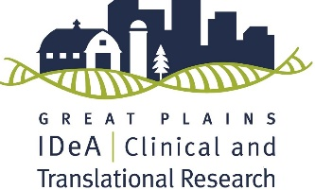
PRINCIPAL INVESTIGATOR(s):
INSTITUTION(s):
RANK(s):
EMAIL(s):

REQUIRED LETTER OF INTENT TEMPLATE:
GREAT PLAINS IDeA-CTR TEAM RESEARCH PILOT GRANT

TITLE OF PROPOSED STUDY:

SPECIFIC AIMS: Provide aim statements. Be succinct. Only include the aims statements here, do not include any introductory content.
Aim 1:
Aim 2:

SIGNIFICANCE AND SCIENTIFIC PREMISE:
Research Priorities: Briefly describe how your project aligns with the GP IDeA-CTR priority areas and the significance of the proposed study.
Scientific Premise: Briefly describe the scientific premise (i.e., the strengths and weakness of the data and previously performed work which the proposal is built upon) of your study based on existing research findings.

APPROACH:
CTR Spectrum: Identify the level of research on the CTR spectrum as pre-clinical, clinical, clinical implementation or public health.
Study objective(s): Describe the primary (and secondary if applicable) objective(s) of the study.
Study design: Describe the design of the study, including the model or population that will be studied, as well as the major assessments that will be performed. Describe the study setting, including, if applicable information on healthcare or community settings where the research will be conducted.
Study outcome(s): Provide information on the primary outcome(s) of the study and, if applicable, secondary outcomes.
Analytic plan: Provide a brief overview of the analytic plan. Where appropriate, provide sample size and power calculations.

TEAM:
Describe the identity and role each team member (including all principal investigators, co-investigators (if applicable) and collaborators (if applicable)) will play in the proposed research project. Provide evidence of prior productivity of the team (including prior publications and/or funding). If applicable, provide rationale for the addition of new team members to the previously existing research team.

ANTICIPATED IMPACT:
Describe the potential impact of the study with a focus on the priority areas described in the call for proposals. This section should be written for a broad audience, using lay language, similar to how you would describe your research to a neighbor or family member who is unfamiliar with your research.

References (not included in 2-page count).

NOTE: DO NOT CHANGE MARGINS OR FONT SIZE WITHIN THE TEMPLATE.

