Artificial Intelligence/Machine Learning

Data Science Pilot Award

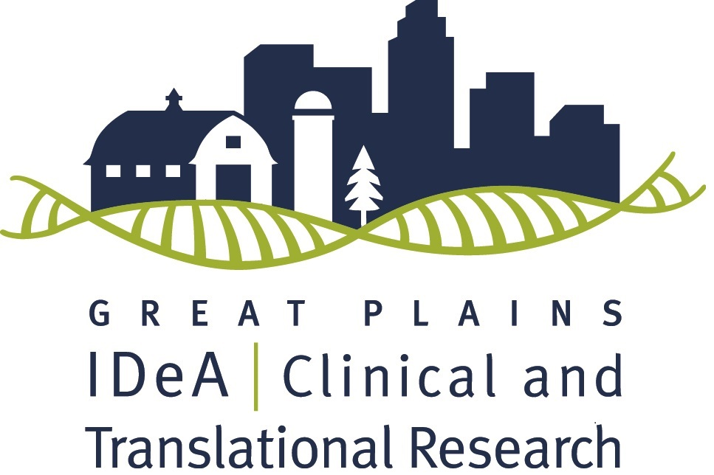

Deadline: Friday 12/9/2022 by 5 PM
The Great Plains IDeA-CTR Network is pleased to announce an opportunity for Data Science pilot funding through an NIH/NIGMS grant. Successful applicants will receive up to $30,000 in direct costs for a one-year project, as well as access to resources of the Great Plains IDeA-CTR to support their research efforts. Project starting date will be July 1st, 2023.

To learn more about the GP IDeA-CTR please visit our website.

If you have any questions, contact Heather Braddock (heather.braddock@unmc.edu

or call 402.559.9870).

The Great Plains IDeA Clinical and Translational Research Network (GP IDeA-CTR) is announcing a call for pilot proposals using and/or developing Artificial Intelligence/Machine Learning (AI/ML) techniques to address a clinical or translational research issue. Examples of relevant topics include, but are not limited to:
- Drug target evaluation
- Mechanisms of action of therapeutics
- Optimization of clinical trials
- Subject identification, recruitment, and/or retention
- Improving the diversity, equity and inclusiveness in biomedical research and its outcomes
- Social determinants of health
- Prediction of disease subtypes
- Developing diagnostic tools using deep learning algorithms
- Disease survival and risk prediction using AI/ML
- Disease surveillance
- Acquisition and analysis of real-world, health-relevant data (e.g., from wearables/smart devices)

The skills in AI/ML with application to the clinical data become increasingly significant in conducting cutting-edge clinical research in modern era. Through the GP-IDeA CTR Cores, we will advocate interdisciplinary collaborations for the research in these topics by leveraging the AI/ML technologies. The proposals will be judged based on the ability of the research project to impact research processes designed to improve the health of our community.

Eligibility:
- PI(s)must be current full-time faculty at a participating institution
- Eligible to apply for NIH research grants
- Research must have a focus on relevant clinical and/or translational research
- Note: You are not eligible to be a Principal Investigator (PI)/Lead if you are a PI/Lead from any other IDeA program (e.g. INBRE, COBRE, CTR) that will overlap at the time of this award.

Participating Institutions and Contacts:
- Boys Town National Research Hospital (BTNRH) – Chris Stecker (chris.stecker@boystown.org)
- Children’s Hospital and Medical Center (CHMC) – Ann Anderson Berry (alanders@unmc.edu)
- Creighton University (CU) – Peter Steyger (petersteyger@creighton.edu)
- Omaha VA Medical Center (O-VAMC) – Fred Hamel (fghamel@unmc.edu)
- University of Nebraska at Kearney (UNK) – Kimberly Carlson (carlsonka1@unk.edu)
- University of Nebraska-Lincoln (UNL) – David Hansen (dhansen1@unl.edu)
- University of Nebraska Medical Center (UNMC) – Sarah Holstein (sarah.holstein@unmc.edu)
- University of Nebraska at Omaha (UNO) – Sara Myers (samyers@unomaha.edu)

Application Deadline: December 9, 2022
Earliest Funding Start Date: July 1st, 2023 (pending review, NIH, and all other regulatory approvals)
Funding will depend on the 1) Scientific and technical merit of the proposed project as determined by scientific peer review, 2) Availability of funds, 3) Relevance of the proposed project to the Great Plains IDeA-CTR program priorities, and 4) Approval by the officials funding the grant.
Funding: We will award 1-2 awards of up to $30,000 each

Full Application Process:
      - Applying to the program is done centrally through UNMC’s REDCap portal. To submit your application, please click here.
      - If you are new to REDCap or have any difficulties during the application process, please contact the Research Information Technology Office (RITO) at 402-559-4878.
      - Once your application has been submitted, you will receive a confirmation email from REDCap.
Full proposal required application materials:
Compile the documents listed below in REDCap in the following order:
      - NIH Face Page (download and complete Form Page 1 here). This does not need to be signed by an institutional official but we strongly encourage you to work with your Grants Administrator or Sponsored Programs office to ensure that all fields on the NIH Face Page are complete and correct.
        - Project dates will be July 1, 2023 – June 30, 2024.
- NIH format Biosketch (for current version, download here). The recently updated NIH biosketch format must be included for the principal investigators and all other key personnel.
- Project summary (limited to 30 lines or less of text, .5 margins, Arial size 11)
  - Include the project’s broad, long-term objectives and specific aims. Include a description of the research design and methods for achieving the stated goals as well as the potential long-term impact the study could have on population health. Write in plain language, so even a non-scientist can understand the importance and impact of the project.
- Research Plan: this portion is limited to three pages in total
- Specific Aim(s) (one page maximum)
- Research Strategy
    - Significance: a) the scientific premise of the proposed research--the strengths and weaknesses of the research that is used to form the basis for the proposed research question; b) can include preliminary data, although not required; c) relevance to clinical translational research.
    - Innovation: a brief summary of how the research project moves the current field forward and incorporates novel concepts, approaches, methodologies, instrumentation or interventions.
    - Approach: Experimental design, including steps taken to ensure scientific rigor (robust and unbiased experimental design), sample, measures, procedures, analysis, interpretation and reporting of results, explained as appropriate for a pilot project, and consideration of key biological variables, if applicable (please see guidelines here).
    - Team: Describe the identity and role each team member (including all principal investigators, co-investigators (if applicable) and collaborators (if applicable)) will play in the proposed research project.
- Plans for extramural funding applications (e.g., to NIH or other agencies, please specify) upon successful completion of this project.
- Literature cited (not part of the 3 pages).
- If your project meets the NIH definition of human subjects research, you must include a Protection of Human Subjects section (as required by NIH grants; follow the “A Protection of Human Subjects section” which can be accessed via the link above). The Protection of Human Subjects section should also include sections for Inclusion of Women & Minorities and Inclusion of Children. You are also required to complete Human Subjects education (e.g., Collaborative IRB Training Initiative (CITI) training) and submit a copy of the certificate to the GP IDeA-CTR, if awarded.
- Regulatory approvals: If your project includes human subjects, your institutional IRB approval is required before funds can be released.
- To reduce potential funding delays, protocols should be submitted to the IRB for approval within 15 days of notification of award, with final approval sent to our office within 60 days. If IRB approval is not needed, an exemption letter or email from the IRB is still required if the project involves human subjects or data from human subjects.
- Budget
- Complete the budget form on page 5 of this document.
- Complete a Budget Justification document outlining the rationale for all research costs is required (NIH format; on a separate page, explain all expenses that appear in the budget including duties of personnel, use of supplies, other expenses, subaward costs, etc.).
- Student/post-doctoral stipend is not allowed (they must be paid through your institution’s payroll system) but student/doctoral salary/wages are permissible. Wages for technical personnel are permissible.
- Equipment (>$5,000 per item) is not allowed.
- Renovation is not allowed.
- Honorariums are not allowed.
- Domestic travel is allowed if it is directly related to the conduct of the research project and not for presentation of the results. International travel is not permissible.
- Indirect costs (F&A) associated with pilot grants will be awarded to the investigator’s institution for NIH-funded pilots. Please work with your Sponsored Programs office to ensure that your proposal budget includes your institution’s correct F&A rate. Additional pilot funds may be funded by partner institutions, rather than NIH, and these institutionally designated awards will not include indirect costs.
- Provide a completed budget from subcontractor(s), only if applicable. If applicable, use the same budget template included below. Make sure to include subcontract indirects in your direct costs.
- Appendices will not be accepted.

Review Process of Full Proposals
      - Three research content reviewers, including one biostatistician or bioinformatician, will provide critiques on each application.
      - The review process will include other considerations, such as relevance to the Great Plains IDeA-CTR program research priorities, the strength of the interdisciplinary team based-approach and the potential for future extramural funding.
      - The Pilot Review Committee will suggest ranking to the Steering Committee.
      - The Steering Committee will make recommendations for funding, which will be forwarded to the External Advisory Committee and NIH Program Officers for final approval.

Expectations of Pilot Awardees

- Become a member of the GP IDeA-CTR via our website.
- Remain current on all regulatory training and approvals and provide all updated approvals to the GP IDeA-CTR Program Coordinator via email - heather.braddock@unmc.edu.
- Meet with Pilot Program leadership at 6 months.
- Complete an electronic progress report at 6 months and a final written report at the conclusion of the funding period.
- Participate in a one-hour research studio at the end of your funding period.
- Complete the NIH annual progress report.
- Attend the GP IDeA-CTR Annual Scientific Meeting where you will provide a poster to discuss during a networking session, as well as meet with and discuss your project and progress with our EAC members and NIGMS Program Officers.
- Provide follow-up for the duration of the parent grant.
- Cite the GP IDeA-CTR/NIGMS grant in funding, publications, and presentations.

DETAILED BUDGET (Direct costs only) | FROM  7/1/2023 | THROUGH  6/30/2024 | GRANT NUMBER  Data Science

List PERSONNEL (Applicant organization only)
Use Cal, Acad, or Summer to Enter Months Devoted to Project
Enter Dollar Amounts Requested (omit cents) for Salary Requested and Fringe Benefits
NAME | ROLE ON PROJECT |  |  | Cal.  Mnths | Acad.  Mnths | Summer  Mnths | SALARY REQUESTED | FRINGE BENEFITS | TOTALS
 | PD/PI
SUBTOTALS
CONSULTANT COSTS

EQUIPMENT (Itemize)

SUPPLIES (Itemize by category)

TRAVEL

INPATIENT CARE COSTS
OUTPATIENT CARE COSTS
ALTERATIONS AND RENOVATIONS (Itemize by category)

OTHER EXPENSES (Itemize by category)

SUBTOTAL DIRECT COSTS FOR NEXT BUDGET PERIOD |  |  |  |  |  |  |  |  | $
CONSORTIUM/CONTRACTUAL COSTS |  |  | DIRECT COSTS
CONSORTIUM/CONTRACTUAL COSTS |  |  | FACILITIES AND ADMINISTRATIVE COSTS
TOTAL DIRECT COSTS FOR NEXT BUDGET PERIOD (Item 8a, Face Page) |  |  |  |  |  |  |  |  | $
PHS 2590 (Rev. 03/2020 Approved Through 02/28/2023)

