Great Plains IDeA-CTR Community-Engaged Research Institute for CTR
How to craft an NIH Biosketch
November 9, 2022

Hand Outs

- NIH biosketch examples
  - Personal Information and Personal Statement
    - Examples 1 and 2 Pages 2-3

  - Positions, Scientific Appointment, and Honors Page 4
    - Example 1

  - Contributions to Science Page 5
    - Examples 1 and 2

- References Page 6

- PowerPoint Presentation pdf file See separate document

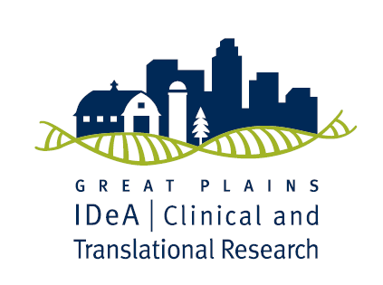
OMB No. 0925-0001 and 0925-0002 (Rev. 12/2020 Approved Through 09/30/2024)
- Personal Information and Personal Statement Fictitious Example 1 ¹

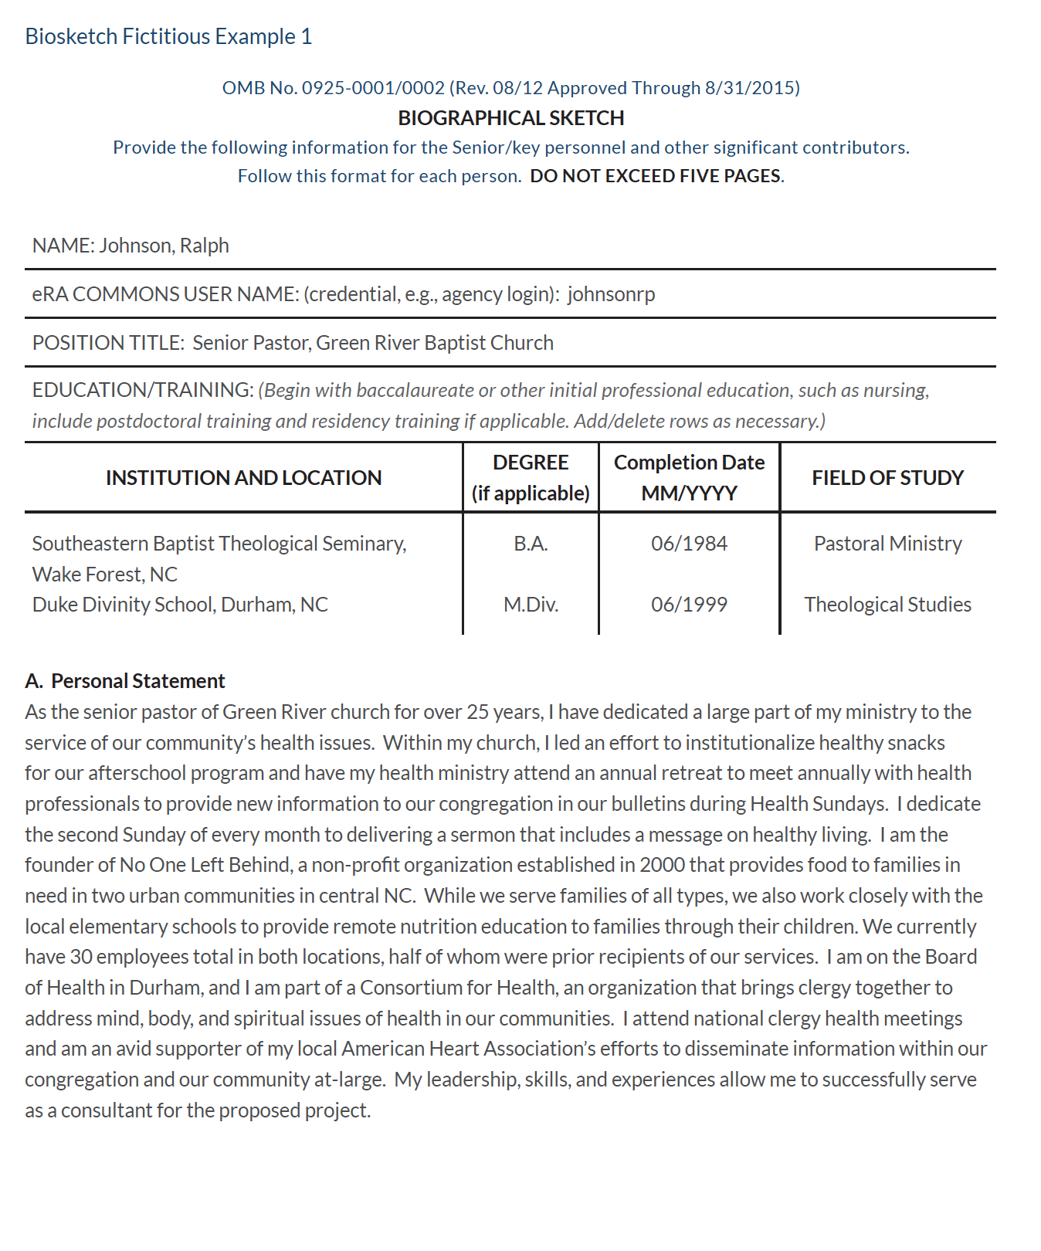
OMB No. 0925-0001 and 0925-0002 (Rev. 12/2020 Approved Through 09/30/2024)
- Personal Information and Personal Statement Fictitious Example 2 ¹

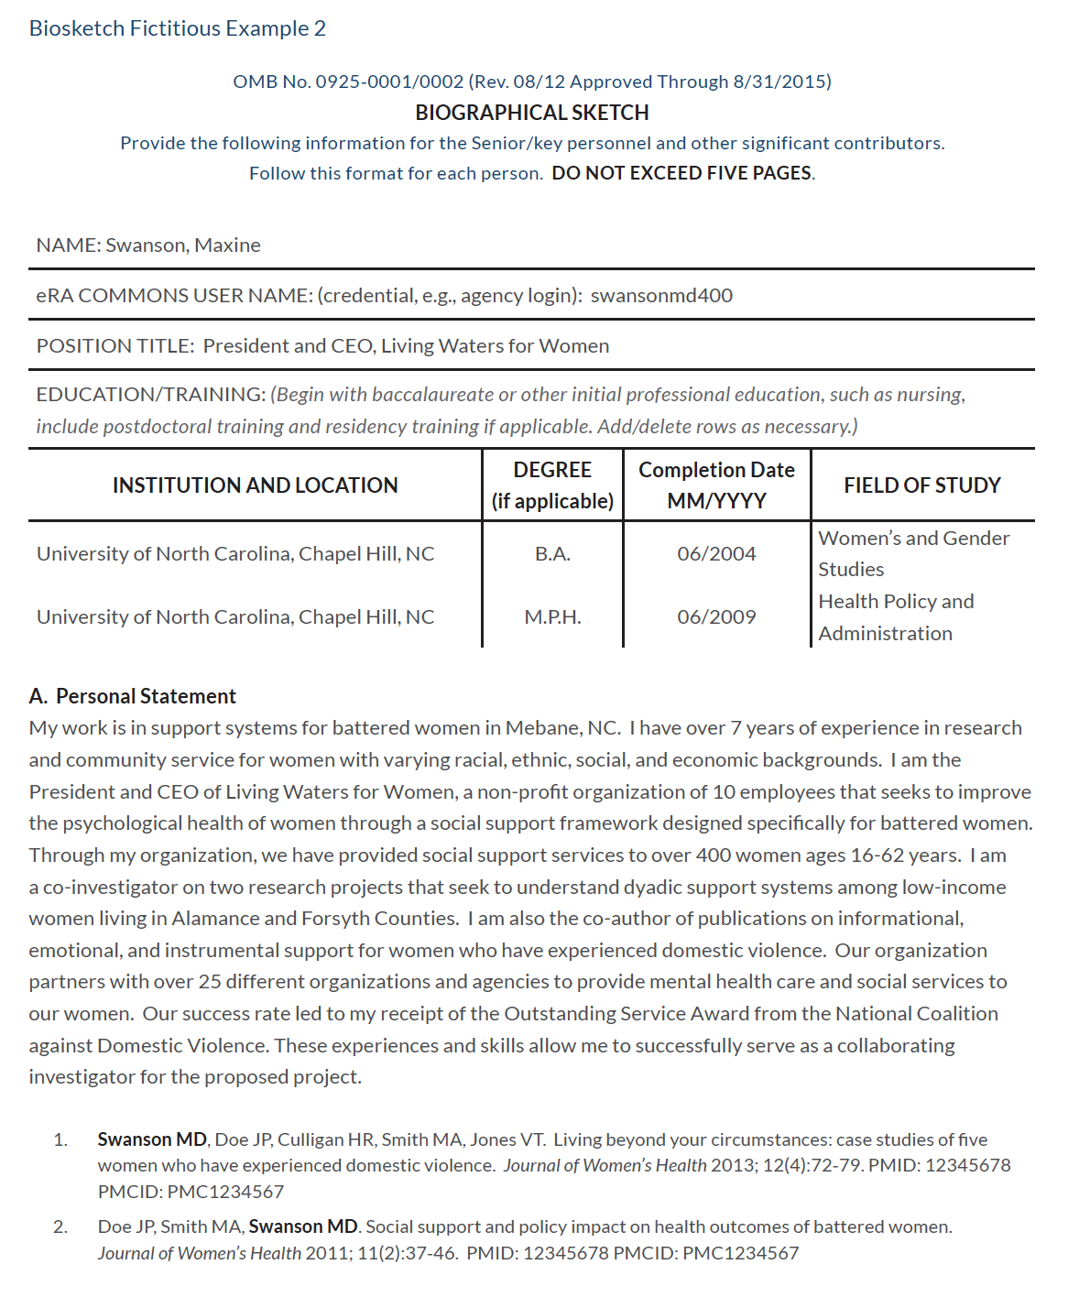

- Positions, Scientific Appointments, and Honors Fictitious Example 1 ²
Start in reverse chronological order (current to oldest)

B. Positions, Scientific Appointments and Honors

2000 - Founder and President, No One left Behind, Durham and Wake Forest, NC
1988- Senior Pastor, Green River Baptist Church, Durham, NC
1984-1988 Associate Pastor, Rock of Salvation Baptist Church, Wake Forest, NC

- Contributions to Science Fictitious Example 1 ³

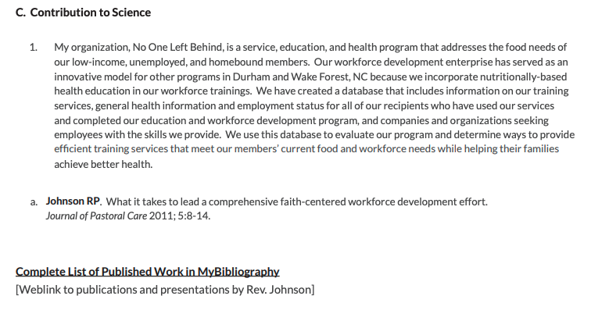

Contributions to Science Fictitious Example 2 ³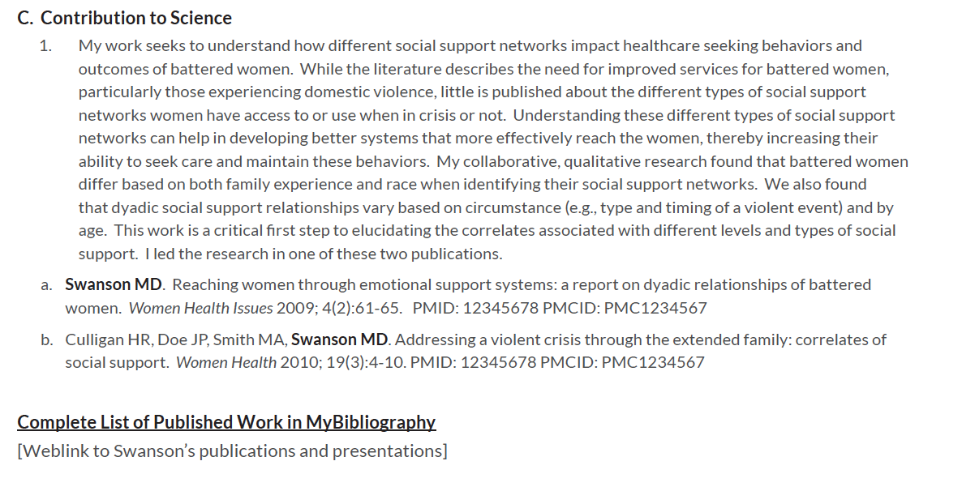

REFERENCES

- Personal Information and Personal Statement Fictitious Example 1 and 2
The University of North Carolina at Chapel Hill, Community Partner’s Guide
https://communityengagement.uncg.edu/wp-content/uploads/2014/07/CAGAT_Community_Partners_Guide_20160722.pdf
Pages 91 and 93

- Positions, Scientific Appointments, and Honors Fictitious Example 1
The University of North Carolina at Chapel Hill, Community Partner’s Guide
https://communityengagement.uncg.edu/wp-content/uploads/2014/07/CAGAT_Community_Partners_Guide_20160722.pdf
Page 92
Note: This section was modified in the example to comply with the current NIH biosketch format for information to be in reverse chronological order.

- Contributions to Science Fictitious Examples 1 and 2
The University of North Carolina at Chapel Hill, Community Partner’s Guide
https://communityengagement.uncg.edu/wp-content/uploads/2014/07/CAGAT_Community_Partners_Guide_20160722.pdf
Page 92 and 94

